**Azure DevOps**

* In the simplest terms, Azure DevOps is the evolution of VSTS (**Visual Studio Team Services**).
* It is the result of years of using their own tools and developing a process for building and delivering products in an efficient and effective Way.
* Web Site: <https://dev.azure.com>

**What is “DevOps”?**

* DevOps is a Software Development Methodology that combines Software Development (Dev) with Operations /Production (Ops).
* The goal of DevOps is to shorten the systems development life cycle while delivering features, fixes, and updates frequently in close alignment

with daily Operations

**A defining of DevOps is:**

**“DevOps is a set of practices intended to reduce the time between committing a change to a system and the change being placed into normal production, while ensuring high quality”.**

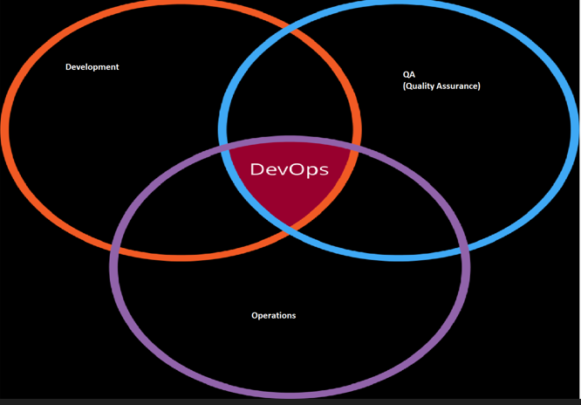

DevOps typically includes the following Key Topics and Tools:

• **Coding** – code development and review, source code management tools,

code merging

• **Building** – continuous integration tools, build status

• **Testing** – continuous testing tools that provide feedback on business risks

• **Packaging** – artifact repository, application pre-deployment staging

• **Releasing** – change management, release approvals, release automation

• **Configuring** – infrastructure configuration and management, infrastructure

as code tools

• **Monitoring** – applications performance monitoring, end-user experience

**“DevOps” and Agile Software Development**

• The need for DevOps arose from the increasing success of Agile Software Development

• Organizations wanted to release their Software faster and more frequently

**Goals with “DevOps”**

• Improved deployment frequency

• Faster time to market

• Lower failure rate of new releases

• Shortened lead time between fixes

• Faster mean time to recovery (in the event of a new release crashing or otherwise disabling the current system)

**Start using Azure DevOps**

Go to the Azure DevOps Web Site and register for the Service.

Web Site: <https://dev.azure.com>

**Create New Project:**

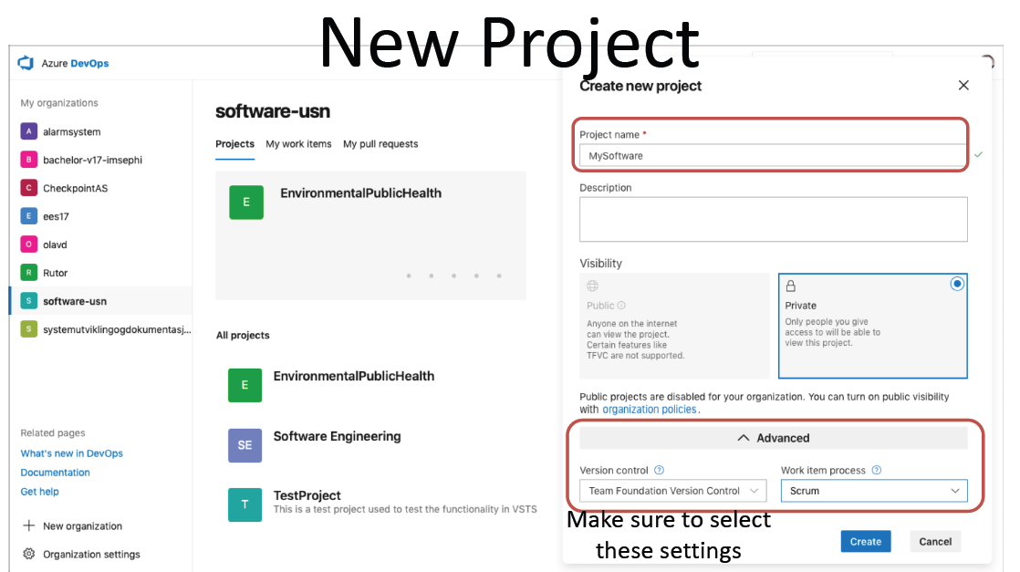

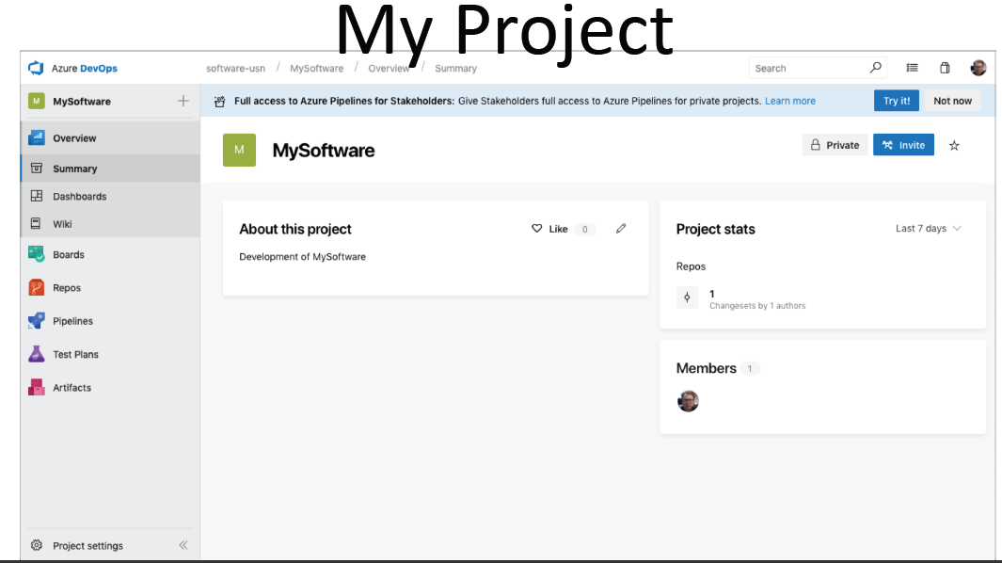

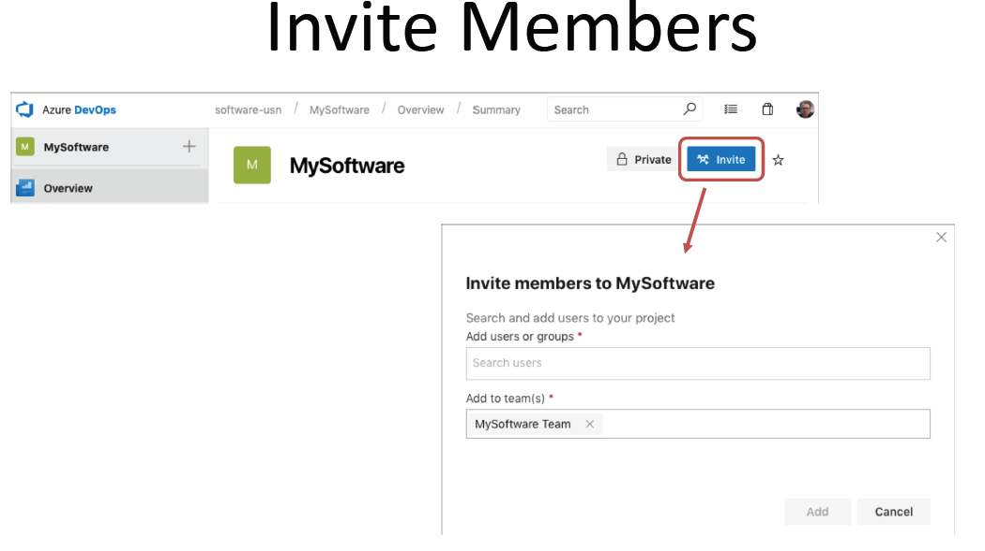

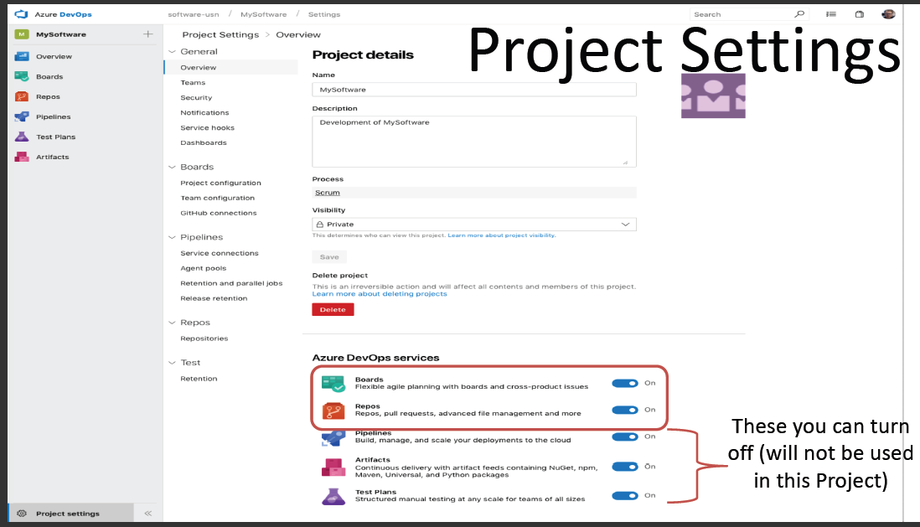

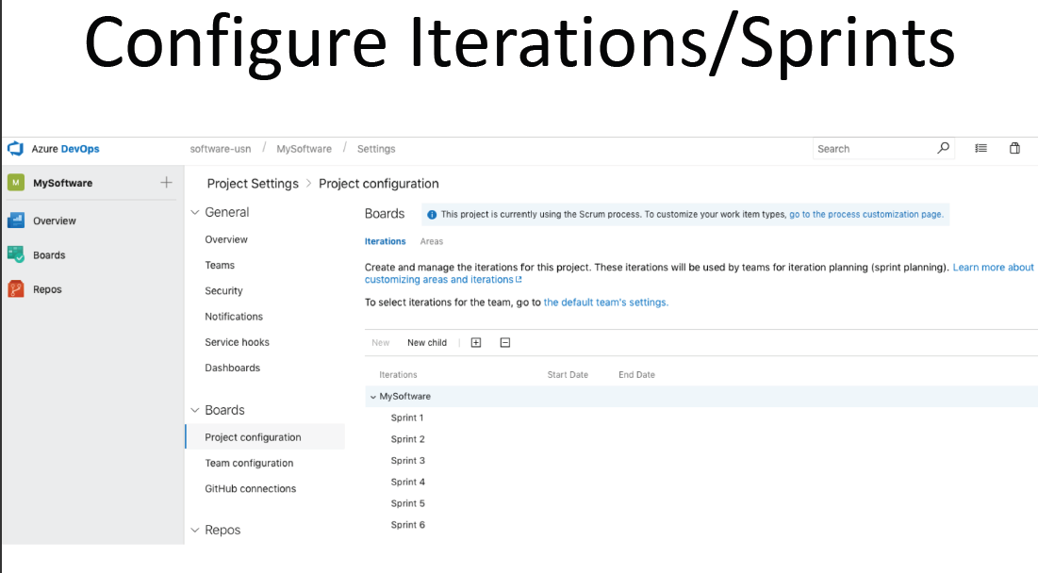

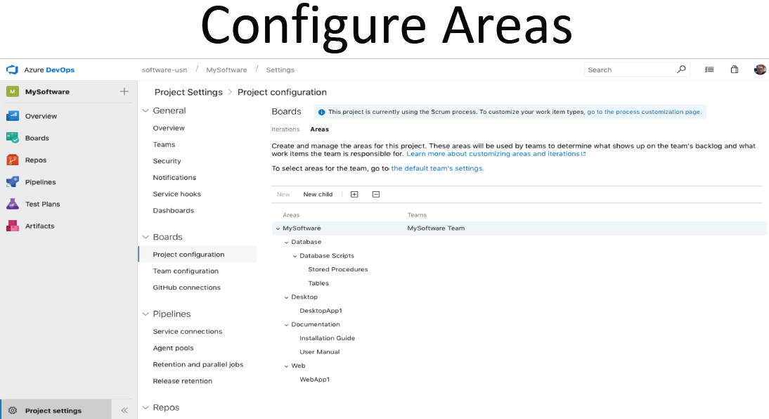

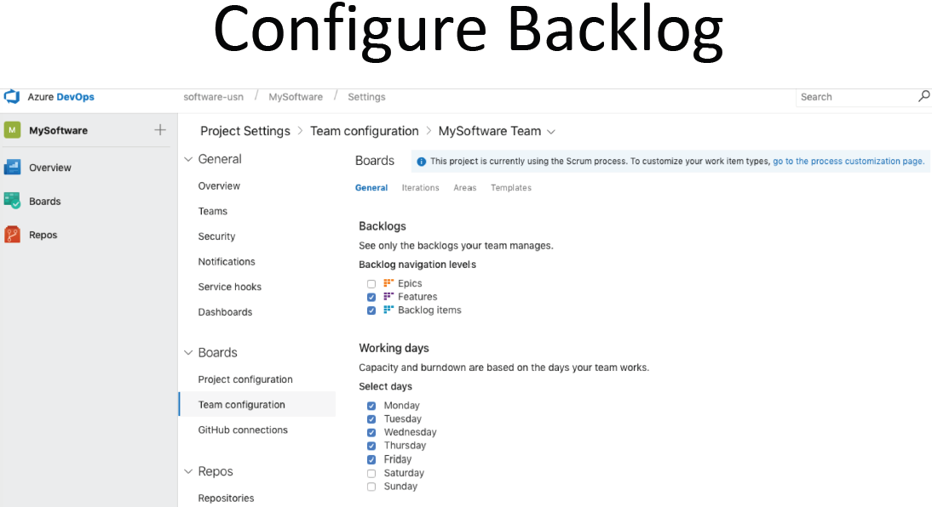

**Work Items:**

